A Wearable Device for Cueing for the management of drooling, and monitoring of symptoms, in people with Parkinson’s

PARTICIPANT INFORMATION SHEET
Study Short Title: Cue Band
I would like to invite you to take part in a research study. Before you decide, I will go through the information sheet with you and answer any questions you have to enable you to understand why this research is being done and what it will involve for you. This should take about 10 minutes. Talk to others about the study if you wish. Please ask if there is anything that is not clear.
- What is the purpose of the study?
Drooling is a common symptom of Parkinson’s due to people experiencing issues with swallowing due to decreased automatic swallow. Currently, treatments aim to decrease the production of saliva however, saliva is important for good oral health. We have designed a wearable wrist device that issues cueing via a vibration as a method to increase frequency of swallowing. We would like to understand if the device helps people with Parkinson’s to swallow more frequently to prevent drooling. We will compare the device with an application (App) downloaded onto your Smartphone device.
- Why have I been invited?
You have been invited to take part as you have self-identified as experiencing a problem with swallowing and drooling and you own a Smartphone that allows you to download an Application.
- What will happen to me if I take part?
You will be asked to take part in an eight-week cueing method intervention study. This will involve being asked to take part in two different methods that will provide cueing (a vibration) for swallowing.
You will be asked to wear a discrete and comfortable device that can be worn on the wrist, referred to as Cue Band, and you will be asked to use the Smartphone app. We would like you to take part in the cueing methods for 6-weeks, 24 hourly. To do so, you will be asked to download an App on your smartphone device that will allow you to access the software used for the cueing methods. Once downloaded, you will be randomly allocated to receive either the Cue Band method for cueing or the Smartphone method for Cueing. You will complete your first cueing method for the first 3-weeks, followed by the alternative cueing method for the following 3-weeks. The Cue Band will be posted out to you for free and will be yours to keep.
Following the 6-week intervention, you will be asked to stop using the cueing methods for a period of 3-weeks prior to further assessment. This part of the study is optional and you can carry on using your preferred cueing method if you would prefer to.
Once you have finished the intervention, you can set up your preferred prompting method for example, the Cue Band or Smartphone only, or you can disable and remove the mobile applications if you no longer wish to use them.
Research Assessments
We would like you to complete research assessments that can be completed using the mobile App. This includes a daily diary (8-weeks in total, and further 3 weeks for optional add on study) and questionnaires (a maximum of 4 in total). Please read the following section that describes the research assessments.
Daily Dairy
Before you begin the cueing intervention, we would like you to complete a daily diary for 2weeks. This will involve completing information on how severe your drooling is and you can provide any additional comments or reflections on your experiences that day. We would like you to maintain completing your daily diary throughout the 6-week intervention (during wearing the Cue Band and using the Smartphone device, only). This should take 10-15 minutes to complete.
Questionnaires
You will be asked to complete questionnaires before and after using the cueing methods. This will include information on your age, sex and Parkinson’s related information for example, time since diagnosis and information on swallowing, drooling and your quality of life. If you decide to stop using the cueing methods for a period of 3 weeks at the end, we will ask you to complete the questionnaires again at the end of the 3-weeks. The questionnaires will take approximately 30 minutes to complete.
Optional Interview
We would like to understand your experience of using the cueing methods and you may be invited to take part in an optional interview. The interview will take place at a date and time that is convenient for you and can be completed over a telephone call or a video call. The interview may last approximately 30 minutes and will be recorded with the use of a Dictaphone. Following transcription of the interview, the recording will be destroyed.
Cue Band
The Cue Band software is a mobile App that will be downloaded on your Smartphone device. This Cue Band is discrete and comfortable to wear and is waterproof. You will be provided with instructions via the App to create a 7-day cueing schedule of when you would like the device to start and stop cueing (vibration), as well as being able to change the intervals and intensity of the vibrating cues. The Cue Band will capture information on your physical activity and sleep. We would like you to wear the device for the 3-weeks, 24 hours a day –.
To register your interest in the study please visit https://cue.band/
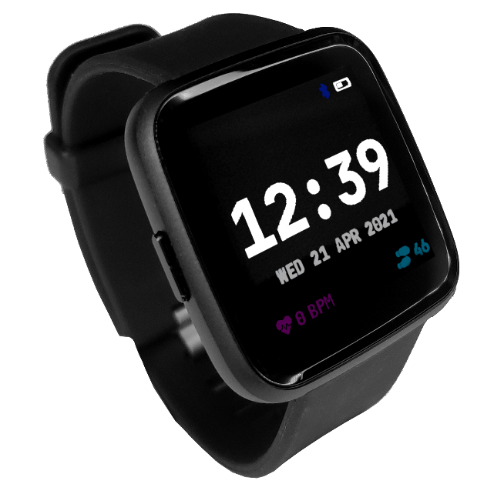

- Do I have to take part?
It is up to you to decide to join the study. You do not have to take part. If you agree to take part, you will be asked to sign a consent form. The consent form can be completed on the mobile App, during a clinical visit or you can ask the research team to complete postal or witnessed consent – the researcher will discuss the options with you. You will be provided with a copy of the consent form to keep. You are free to change your mind and withdraw from the study at any time and do not have to give a reason. Deciding not to take part, or withdrawing from the study, will not affect your current or future medical care in any way.
- What are the potential disadvantages and risks of taking part in this study?
There are no known disadvantages or risks to taking part in this study.
- What are the possible benefits of taking part?
The benefit of taking part in this research is that it will help us to gain a greater understanding of the acceptability and effectiveness of using a novel cueing method for swallowing and drooling. We hope that the device will help people with Parkinson’s and may be a potential alternative to medication.
- What if there is a problem?
If you have any concern or complaint about any aspect of this study you should contact us by phone and ask to speak to the researcher who will do their best to answer your questions. The researcher can be contacted on 0191 293 4087 (office hours). For further independent advice you can contact the patient advice and liaison service on 0800 032 0202.
- Will my taking part in the study be kept confidential?
Yes. We will follow ethical and legal practice and all information about you will be handled in confidence. All information which is collected about you during the course of the research will be kept strictly confidential, and any information about you will have your name and contact details removed so that you cannot be recognised. The research team may contact your direct care team should any issues be identified that are important for your wellbeing and safety. In the event of disclosure of confidential information, confidentiality will be broken if any of the following are identified; malpractice of staff, evidence of harm to participants/service users, incidents relevant to the criminal justice system, adverse effects on wellbeing and health.
- What will happen to the results of the research study?

We will publish the results of the study in scientific journals and present the findings at meetings. We will use the quotes from the interviews when publishing our findings. No personal information will be identifiable in any report, paper or presentation.

Who has reviewed the study?
All research in the NHS is looked at by an independent group of people, called a Research Ethics Committee. This study has been reviewed and approved by a Local Research Ethics committee, who ensure that you are protected in terms of your health and your rights. This study has also been reviewed by the Health Research Authority and Northumbria Healthcare NHS Foundation Trust is the sponsor for this study.

How will we use information about you?
All the information that you provide during this research will be securely stored in locked files and a secure computer database. The answers you provide will be kept separate from your personal information (such as your name and contact details) and will only be identified by a unique code number. No individually identifiable information will be stored outside the main research team. No individual will be identified or identifiable in any publication arising from the research. We will keep all information about you safe and secure. Identifiable date and research data generated as part of the study will be stored securely for 5 years following conclusion of the study. The rest of this section gives more detail on how your information will be used during the study.
Your rights to access change or move your information are limited, as we need to manage the information in specific ways in order for the research to be reliable and accurate. If you withdraw from the study, we will keep the information about you that we already have obtained. To safeguard your rights, we will use the minimum personally-identifiable information possible.
Northumbria Healthcare NHS Foundation Trust will use your name, NHS number and contact details to contact you about the research study, and make sure that relevant information about the study is recorded for your care, and to oversee the quality of the study. Individuals from Northumbria Healthcare NHS Foundation Trust may look at your medical and research records to check the accuracy of the research study. The only people in Northumbria Healthcare NHS Foundation Trust who will have access to information that identifies you will be people who need to contact you about taking part in the study to or audit the data collection process. The people who analyse the information will not be able to identify you and will not be able to find out your name, NHS number or contact details. Once we have finished the study, we will keep some of the data so we can check the results. We will write our reports in a way that no-one can work out that you took part in the study.

What are your choices about how your information is used?
You can stop being part of the study at any time, without giving a reason, but we will keep information about you that we already have. We need to manage your records in specific ways for the research to be reliable. This means that we won’t be able to let you see or change the data we hold about you.

Where can you find out more about how your information is used?
You can find out more about how we use your information at www.hra.nhs.uk/information-about-patients/ and by asking one of the research team whose details are shown below. For further independent information about being involved in a research study, please contact the Patient Advice and Liaison Service on telephone number 0800 032 02 02.
Contact for Further Information
Researcher: Lorelle Dismore
Direct line telephone: 0191 293 4087

Thank you for reading this information sheet.

