Customer care and feedback
Key performance indicators 2018

In 2018, Parkinson’s UK received 2,027 feedback items

- 1649 positive feedback (compliments)
- 226 neutral feedback (comments and/or suggestions)
- 152 negative feedback (147 complaints, 5 formal complaints)

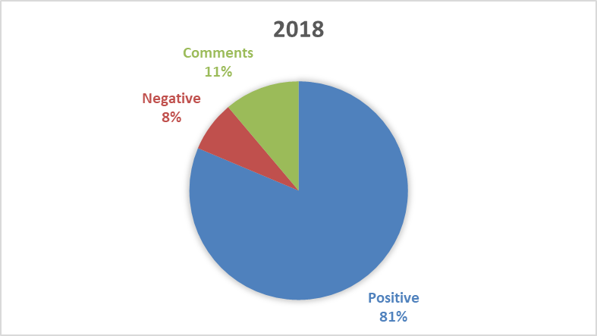
Figure 1: Feedback received – 2018

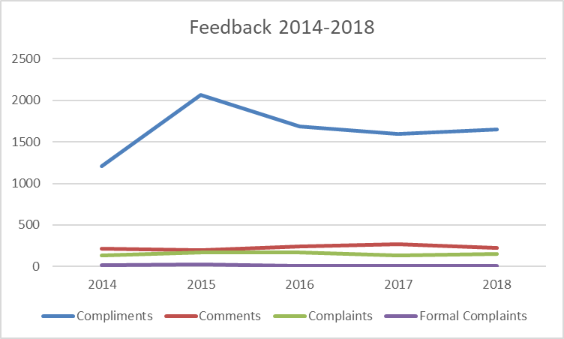
Graph 1: Feedback received 2014 – 2018

Key Performance Indicators

Feedback – positive v negative
The feedback key performance indicator serves to monitor the ratio between positive and negative feedback received. Our target is to not receive any more than 20% negative feedback in any given year.

Year | 2014 | 2015 | 2016 | 2017 | 2018
Target | <20% | <20% | <20% | <20% | <20%
Actual | 11% | 9% | 13% | 9% | 9%
Table 1: Percentage of positive to negative feedback since 2014

As shown in the table above, in 2018 91% of feedback was positive/complimentary, and we performed well against target of <20% negative feedback.

Response times
As outlined in our customer pledge, we aim to respond to correspondence and queries within 5 working days. Our target is that a minimum 85% of feedback will be responded to within the stated time frame.

Year | 2014 | 2015 | 2016 | 2017 | 2018
Target | >85% | >85% | >85% | >85% | >85%
Actual | 89% | 88% | 92% | 94% | 97%
Table 2: Percentage of feedback responded to within 5 working days since 2014

Complaints escalated to formal stage
We aim to resolve all complaints first time and to the satisfaction of the individual complaining. Where this isn’t possible, the complaint moves to formal stage. Our key performance indicator is that no more than 10% of complaints in the year are escalated to formal stage.

Year | 2014 | 2015 | 2016 | 2017 | 2018
Target | <10% | <10% | <10% | <10% | <10%
Actual | 11% | 13% | 2% | 3% | 4%
Table 3: Percentage of complaints escalated to formal level

In 2018 we retained our Customer Service Excellence Standard accreditation for the 6th year, following the annual compliance re-assessment visit, which took place in October.

We are achieved full compliance against all the elements. In addition, we were awarded Compliance Plus in 2 areas, bringing our Compliance Plus elements up to 6 in total:

- Hard to reach and/or disadvantaged focus
- Community engagement
- Staff customer focus
- Improving information range/channels
- Strong partnerships
- Activity delivery with positive outcomes

For further information, including feedback topics and trends, please refer to the full Customer Feedback 2018 report on the following page.

Customer Feedback 2018
Full report

“It was you that sorted me, no one else. When you left I felt so much better and I have continued to feel better. I have no words to thank you”
Parkinson’s Local Adviser client, Q3 2018

The charity’s continuing aim to put the views of people affected by Parkinson’s at the heart of everything we do is underpinned by various mechanisms to help us achieve this goal. Our feedback channels provide an immediate way for individuals to share their views about the charity or aspects of living with Parkinson’s. People can contact us and give us their views in numerous ways – online, email, telephone, in person and using our feedback cards.

The feedback gathered is rich and varied. It often shapes our work and provides insight to service-user perception of the charity and an overview of how we’re performing in relation to customer care standards.

This report provides an overview of customer care practice and feedback received during 2018 from people affected by Parkinson’s, supporters, volunteers and others within the Parkinson’s community. Feedback reported on was received through various channels, including online web forms, emails, by phone, post, surveys and in person.

Activity in 2018
To provide context, 2018 was a busy year in relation to supporter contact and service use. These aren’t complete stats but give an overview for our principal customer facing services and activity.
- Helpline answered 20,395 phone calls and 4,441 voicemails; and responded to 2,088* email enquiries (*Jan-Nov only).

- Parkinson’s Local Adviser service received 11,606 referrals and had over 21,944 general enquiries.

- Supporter Services responded to 12,764 calls and 10,165 emails

- Fundraising campaigns and activities included
  - 362,158 Individual Giving and Legacy Marketing mailings
  - 165 emails to 403,053 recipients

Definitions
Feedback includes:
- Comments and suggestions – people sharing their thoughts about the charity and what they think we can change
- Compliments – what people think we have done well
- Complaints – what people think we have done wrong

Formal complaints are complaints:
- That have been escalated from an informal complaint as they were not resolved first time
- Where a person has explicitly said they would like to make a formal complaint

Feedback received in 2018
In 2018 we received 2027 feedback items overall, of which
- 1649 positive feedback (compliments)
- 226 neutral feedback (comments and/or suggestions)
- 152 negative feedback (147 complaints, 5 formal complaints)

Figure 1: Feedback received – 2018

Breakdown of feedback in 2018

2018 | Jan | Q1  Feb | Mar | Apr | Q2  May | Jun | Jul | Q3  Aug | Sep | Oct | Q4  Nov | Dec*
Comments | 31 | 23 | 22 | 20 | 27 | 8 | 22 | 11 | 17 | 16 | 16 | 13
Compliments | 74 | 70 | 93 | 106 | 108 | 84 | 116 | 118 | 95 | 107 | 123 | 555
Complaints | 6 | 12 | 11 | 10 | 14 | 8 | 9 | 12 | 7 | 9 | 14 | 35
Formal Complaints | 0 | 1 | 0 | 0 | 1 | 0 | 1 | 0 | 0 | 0 | 1 | 1
Total | 111 | 106 | 126 | 136 | 150 | 100 | 148 | 141 | 119 | 132 | 154 | 604

Table 1: Breakdown of all feedback – 2018 *December includes a total of 468 positive and 13 negative service satisfaction survey responses
Comparison to previous years
The total feedback items received (n2027) increased slightly compared to 2017.

Feedback type | 2014 | 2015 | 2016 | 2017 | 2018
Compliments | 1205 (77%) | 2066 (84%) | 1684 (80%) | 1593 (80%) | 1649  (81%)
Comments | 216 (14%) | 199 (9%) | 244 (12%) | 267 (13%) | 226  (11%)
Complaints | 131 (8%) | 171 (6%) | 170 (8%) | 136 (7%) | 147  (8%)
Formal Complaints | 15  (1%) | 26  (1%) | 4  (0%) | 4  (0%) | 5  (0%)
Total | 1567 | 2493 | 2102 | 1996 | 2027
Table 2: Feedback by year 2014 - 2018

Graph 1: Feedback by year 2014 - 2018

Positive and negative feedback
Removing neutral comments and suggestions, of the feedback items received, 91% were complimentary and 9% were negative (complaints and formal complaints). Our annual target is to receive no more than 20% negative feedback.

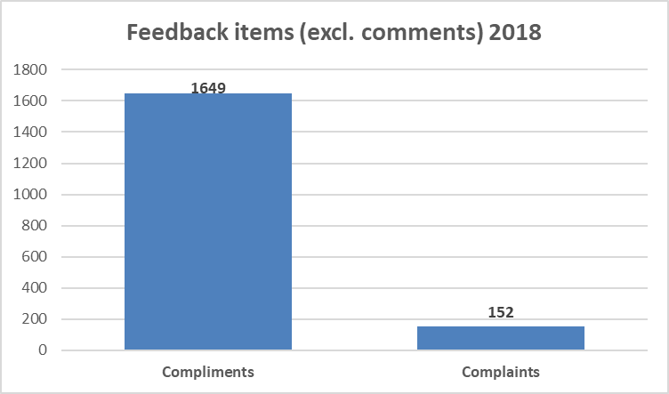
Figure 2: Positive v negative feedback 2018

Compliments
Compliments were received from across the UK, relating to all areas of the charity. And 2018 saw a small increase in compliments (+56) compared with 2017.

The following areas of the charity received particularly strong feedback during the year:

Parkinson’s Local Advisers:
As in previous years, most compliments were about Parkinson’s Local Advisers. Service users expressed that their local advisers were knowledgeable and professional and made them feel supported. Additionally, several compliments detailed how crucial their local adviser was in supporting their application for Personal Independence Payment (PIP) and other benefits.

“I am newly diagnosed with Parkinson’s and I’m very pleased with what is available. My support worker answered all my questions clearly. She also listened well to any problems I had and came up with lots of solutions and organised booklets for my specific problem. Excellent support” -Q1, 2018

“Just to let you know I have been awarded the highest rate for PIP on both daily living and mobility. Many, many thanks for your fantastic support. I really don’t know how I would have got through it without you. We are so pleased about their decision”- Q1, 2018

“It was you that sorted me, no one else. When you left I felt so much better and I have continued to feel better. I have no words to thank you” -Q3, 2018

Written resources and website:
Feedback in relation to our written resources was positive. People expressed that
they found literature to be informative and supportive in helping them manage their condition day-to-day.
“We would like to thank you for all the very helpful articles and publications. Also for your useful and easy to use website!” -Q2, 2018

Events
The events team received a number of compliments. A lot of praise was given around the excellent coordination and organisation of events and the helpfulness of staff.

“Can I just say how well organised this event is, I’ve done it three times and thoroughly enjoyed it, my dad suffered for over ten years with Parkinson’s, so it’s nice to give something back. The staff and helpers were particularly helpful this year as it was such a hot day” -Q3, 2018

“Thank you so much to you and your amazing team. An excellent course, great food stops, mechanics etc and a lovely team!” -Q2, 2018

“The walk was so well organised and the route so easy to follow, it was just lovely to experience the day and the walk with like-minded people” -Q2, 2018

First Steps Programme:
The First Steps Programme was praised for its success in supporting people who have recently been diagnosed with Parkinson’s.

“We both found the first day enlightening and beneficial and are looking forward to attending the second day.” -Q2, 2018

“I cannot thank Parkinson’s UK enough for the excellent First Steps course I recently attended. The two-day course aligned many of the fears that you have when told you have Parkinson's. The presenters where able to relate to us in a way that when dealing with our condition made for it easier to deal with everyday living, whilst encouraging one to deal with the future in a positive way” -Q3, 2018

Policy and Campaigns:
Feedback for the Policy and Campaigns team was positive, specifically in relation to the amount of support received for campaigns and the success of the Campaigner celebration event.

“Well done on the amazing reach of the Employment Support Allowance story”- Q4, 2018

“So important as a volunteer to feel included and appreciated so today was the icing on the cake.” Campaigner celebration event -Q3, 2018

Helpline:
The helpline continued to receive positive feedback from service users this year,
particularly from those who were newly diagnosed. Users found the team to be very supportive and empathetic to their situation and, in certain cases, people felt that the helpline acted as their lifeline.

"My husband was diagnosed with Parkinson’s just 6 weeks ago and in the first few days we felt very alone and rang your helpline on a Saturday morning. The lady who answered was just lovely, very informative and reassuring. Not sure what we would have done without her.” -Q2, 2018

“Many thanks for your time and help this morning. I am very impressed with the level of support which the Parkinson's UK is able to give” -Q1, 2018

Complaint Themes

Formal complaints
In 2018 we received 5 formal complaints have been received with 1 being partially upheld.

Complaint Theme | No. | Upheld
Trading at local groups | 1 | No
Dissatisfaction with SMP and charity spending | 1 | No
Unsolicited contact | 1 | Yes
Staff behaviour | 2 | No

Informal complaints
In 2018 there were 147 complaints at informal level.

Fundraising Directorate (73) | Complaint Theme | No
 | Events e-news (1x member did not like the phrase ‘take a challenge’ being used within the e-news letter as it has connotations of people with Parkinson’s and their carers should be doing more.) (1x member found event mailing to be suggesting inappropriate events, such as marathons, and also found the use of the word ‘challenge’ distasteful) | 2
 | Lack of reply (1x not upheld, letter had not been received by Major Gifts), (2x no reply following membership cancellation letter) (1x not upheld no reply to email, records show reply had been sent out) | 4
 | Lack of support for Fundraisers (1x Lady had not been satisfied with fundraising teams assistance through promotion of her weight loss fundraising challenge. Comments also made about the lack of media coverage Parkinson’s receives in comparison to other charities and conditions) | 1
 | No Acknowledgment following donation (1x not upheld, thank you letter had been sent but are sent 2nd class, 1x Lady had donated in October 2017, no acknowledgment had been received ) (3x no acknowledgement received following donation, donation refunded), (1x local group had not received acknowledgment letter following donation), (1x donations received from wedding, not every supporter received thank you letter) | 7
 | Time and location of Walk for Parkinson’s events (1x Lady contacted events to complain that no Walk had been scheduled in her local area and that the event only runs on Sundays.) | 1
 | Disappointed with shop products (1x complaint about give me time badge and programming of vibrowatch) | 1
 | Disappointed with thank you letter (1x a long standing member had made an in mem donation following her husband’s death, members of her local group were disappointed by the generic thank you letter received) | 1
 | Negative external interview (1x negative interview carried out by Daily Express on Dave Clark, lady wanted to know what influence the PR team had on such interviews) | 1
 | 3rd Party membership fulfilment (1x a new member became concerned that his data could be compromised after learning of the membership process’ external fulfilment) | 1
 | Duplicate membership/donation (1x processing delay led to new member sending two application forms and donations, both being processed, 1x member complained that the charity sends two membership packs to the same address) | 2
 | Unsolicited contact (3x letter had been sent to supporter who had selected no further contact upon donation) (1x supporter received fundraising appeal despite opting out of appeals), (1x supporter disappointed in receiving fundraising appeals following an ‘in memory’ donation to Parkinson’s UK) | 5
 | Use of titles in outbound mail (1x member had not selected a title yet received letter addressed to ‘ms’, furthermore donation forms require a title to be selected) | 1
 | Legacies communication (1x new member immediately received legacy mailing which they found in ill taste), (1x member finds it inappropriate to send out legacy appeals to those with Parkinson’s) | 2
 | Membership expiry discrepancy (1x Member unhappy with lapsed membership system) (1x member received letter informing that their name would be deleted from list if no response but member had renewed their membership-occurred due to SST not receiving renewal before letter sent) (1x member did not receive information on membership renewal and consequently has not received the magazines) | 3
 | Collection tins (1x complaint about the process of volunteers collecting and depositing funds raised by collection tins) | 1
 | Event t-shirts (1x not upheld t-shirts had not arrived on schedule for marathon) | 1
 | Member not receiving The Parkinson (3x mail block had been placed on members record, now removed), (1x oversea member has not received the Parkinson) (1x member has not received The Parkinson) | 5
 | Difficulties making donation (1x supporter was unable to reach supporter services to make donation) | 1
 | Membership list data protection (1x supporter displeased that a relative could not sign for mailing) | 1
 | Online donations (1x supporter unhappy with online donations pages) | 1
 | Parkinson’s Disease Society banking title (1x supporter ended direct debit as they did not like seeing the charities banking name, specifically the word ‘disease’ on their bank statement) | 1
 | Staff rudeness (2014) (1x supporter replied to an appeal email explaining how a member of staff had been unsympathetic and unhelpful following defaulting the London Marathon event) | 1
 | Thank you letter / certificate (1x thank you letter did not correctly reflect the restriction that the supporter had placed on donation), (1x fundraising certificate did not properly reflect the restrictions placed on funds raised) | 2
 | Failure to register supporter for event (1x supporter sent cheque as registration for fundraising event, cheque had been chased but details not passed to fundraising. Supporter withdrew from event and was refunded) | 1
 | Failure to remove details from membership list (2x supporter had requested to be removed from membership list repeatedly, still received mail), (1x failure to removed deceased member from membership list) | 3
 | Mailing lead time (2x member had requested no more mail a month ago, still received mail due to 6 week leadtime) | 2
 | Inaccurate membership lists (1x local group member complained to SST following inaccuracies with local group membership list), (1x mailing sent to old address despite member making contact previously to update address) | 2
 | Frequency of appeals (1x a new member complained that since an initial donation to the charity they have received too many appeal communications), (1x member complained about the amount of appeals and argued this could problematic for vulnerable people) | 2
 | Member not receiving the Parkinson (1x member phoned SST to complain they had been intermittently receiving the Parkinson. This was a known issue as back copies had been sent last year) | 1
 | Direct debit cancellation letter (1x complaint following the receipt and wording of a direct debit cancellation letter) | 1
 | Incorrect images used in fundraising materials (1x incorrect image of James Parkinson used within fundraising materials) | 1
 | Raffle prizes (1x complaint around cash prizes given in raffle) | 1
 | Mosaic (1x complaint around payment complications), (1x mail received with incorrect customer details on pack) | 2
 | Local event organisation (1x anonymous complaint following a local event, no time allowed for breaks, felt as if the walk was longer than advertised, no first aid facilities or consideration of health and safety, stewards were well-meaning but inexperienced) | 1
 | Membership pack not received (2x member phoned SST on behalf of group to explain new members had not received membership packs) | 2
 | Misrepresentation of funds raised at local event (1x local event advertisement did not explain what funds raised would be used for) | 1
 | Member not receiving mail (1x not upheld member had requested no contact) | 1
 | Incorrect details in appeal (1x appeal suggested supporter had not donated in a long period of time, supporter had in fact recently supported the charity through fundraising that had not been picked up in the appeal mailing) | 1
 | Christmas Cards (1x member feels the blank space on the back of the Christmas card should be used for advertising/awareness raising) | 1
 | Unauthorised card payment (1x telebank error led to one supporters card details being attributed to another supporters payment) (1x small amount of money taken from customer’s account without consent) | 2
 | Incorrect title on correspondence with Parkinson’s UK (1x trustee from another charity was unhappy with how a member of staff at Parkinson’s UK had addressed her title using ‘Ms’ instead of ‘Professor’) _ | 1
 | Branch not receiving membership list because of Data Protection (1x branch no longer receiving membership list resulting in making the functioning of the branch difficult) | 1

Support and Local Networks Directorate (34) | Unable to contact local adviser (1x not upheld, lady complained that she had been charged a premium rate calling local adviser and that they could not make contact) | 1
 | Inappropriate behaviour by lead volunteer at local group (1x Parkinson’s Nurse felt intimidated and bullied by lead volunteer at coffee morning. Following investigation bullying claims were dropped but complaint about behaviour upheld.1x lady had attempted to join group but felt lead volunteer was hostile towards her, compliant from 2015) | 2
 | Local communication (1x not upheld, group disappointed they were not informed of celebrity taking part in Walk for Parkinson’s – celebrity did not want PR team to handle publicity of event) | 1
 | No reply (1x member had attended a specific programme and found it unhelpful/unpleasant, call backs had been offered twice by staff but no one has contacted the member to discuss) | 1
 | Local Support look up tool (1x Lead volunteer complained that group activities had been removed from the website, also stated that he did not believe the updates were sufficiently communicated to local groups. 2x volunteer states that the missing information on the website negatively impacts the charities image) (5x members of local group raising concerns over inaccuracies) | 8
 | Funding at group events (1x group member complaint about method of funding for group trip) | 1
 | Bad experience at local class (1x lady felt that a class instructor had treated her husband insensitively) | 1
 | Lack of support from local team (1x Not Upheld local team supported member within remit who had wanted to set up a new local group) (1x supporter did not feel supported by the local team during a dispute with GP surgery), (1x group members felt that a former committee member had been pressured into resigning and not received support from local staff) | 3
 | Lack of empathy at working together event (1x volunteer at a working together event noticed a member of staff talking over a participant and felt this was a lack of understanding and empathy, location unspecified) | 1
 | Data protection changes (1x local group concerned that data protection changes have been implemented without consulting local groups, also concerned that it will make it difficult to maintain contact with people in local areas) | 1
 | Membership lists inaccuracies (1x membership list contained inaccuracies, local networks discussed with local group) | 1
 | Local group literature (1x complaint around the amount of literature sent out to local groups querying whether it is cost effective, mailing believed to be strategy consolation cards but not confirmed) | 1
 | Group membership fees (1x member displeased that group membership and national membership were separated causing confusion) | 1
 | Bullying within local group (1x complaint received following disagreements within a local group. Volunteer Co-Ordinator offered to mediate discussions but member preferred to step away from local group) | 1
 | Local group accessibility (1x due to specific accessibility needs a member was not able to attend certain local group events, leaving them feeling deserted by the local group system) | 1
 | Insensitive Helpline call (1x caller found that the operator, whilst being polite, did not fully listen and instead spoke at them, resulting in an insensitive call) | 1
 | Forum account suspension (2x complaint about member of staff following forum account suspension) | 2
 | Local group order process (1x recourses not available to local groups) | 1
 | Post code search not working properly on website (1x complaint about post code search not accepting towns as input, issue was resolved by Local Networks) | 1
 | Local business advertised on website without consent (1x unhappy that his business details were used on the website without his consent) | 1
 | Complaint about staff member (not upheld) (1x social media comments about the disciplinary round a member of staff being disciplined, not upheld) | 1
 | Lack of support for people living with Parkinson’s (1x complaint about lack of support given for people living with Parkinson’s. Felt under supported as promised treatments and not received them) | 1
 | Frustration at NHS failings (1x member unhappy at NHS failings for seven months, especially their consultant) | 1

Research (2) | Research grant application (1x complaint following grant application, not upheld as application did not meet criteria set out) | 1
 | Incorrect information on Research mailing (1x incorrect date used in email) | 1

Organisational Development (2) | Recruitment (1x fundraiser received generic HR email following a deadline extension on an application due to time spent undertaking a Parkinson’s UK event. Accepts the outcome of the application but feels that more time should have been taken on reply due to the circumstances) | 1
 | Job application feedback (1x person unhappy that they did not receive feedback on why their application was unsuccessful. They have applied for jobs on three separate occasions and felt like ‘if you have Parkinson’s you don’t have a chance’) | 1

Strategic Intelligence and Excellence Directorate (2) | Volunteer educator support (1x Volunteer educator feels that Parkinson’s UK does not do enough to promote the education programme. Complaint also includes dissatisfaction at amended education feedback forms) | 1
 | Your Life, Your Services (1x member felt that the survey asked too much identifiable information) | 1

Digital Transformation and Communications Directorate (8) | New Forum (1x difficulties logging into new forum, account details are invalid, 1x forum user complained following ‘social club’ area on forum had briefly been made accessible to public viewers) | 2
 | Mali Jenkins Fund (1x complain about the length of time it has taken to replace the Mali Jenkins Fund with taking control grant, also questions what had happened with funding since 2015 and why certain areas have been selected for the new programme) | 1
 | Plastic Waste (1x complaint over the use of opaque plastic covering certain mailings) | 1
 | Negative Parkinson’s UK video (1x member had found the tone of the video negative and uninspiring) | 1
 | World Parkinson’s Day video (1x member had found the video to be too negative) | 1
 | The Parkinson (1x member finds the design and style of the Parkinson to be outdated and lack focus on young onset Parkinson’s) | 1
 | Digital focus (1x member dislikes the emphasis placed on the charities digital focus, labelling it ‘smug’ and suggesting more focus should be placed on front line support of people with Parkinson’s within NHS services) | 1

General/CEO Office (4) | Member feels that the charity has ‘lost its way’ (1x member feels that the charity has lost touch with people with Parkinson’s, this is partly due to the changes made to the local team structure, member would prefer to have one point of contact rather than several i.e. local adviser, benefit and employment adviser, volunteer coordinator etc.. member has Steve Ford’s email address to forward further thoughts) | 1
 | Parkinson’s UK support (1x not upheld dissatisfaction by services offered by the charity, involvement team explained charities position and signposted to organisations that are better suited to take forward the specific case) | 1
 | Local group membership lists and data protection (1x complaint around data protection and the discontinuation of mailed membership lists) | 1
 | AGM paperwork (1x member did not receive AGM paperwork, feels discriminated against as they do not have access to a computer) | 1

Animal Aid campaign emails
In addition to unsolicited feedback listed above, between September and December we received around 5,400 emails related to an Animal Aid campaign and the use of animal models by Parkinson’s UK funded research.

The majority of these emails were generic appeal emails and no responses were sent. The Head of Research Communications did respond directly to about 50 appeal emails – this was where the email came from a person with Parkinson’s or other charity supporter.

These 5,400 emails have not been included in our overall feedback figures as they aren’t direct complaints about our services, activities or customer care practice.

You said, we did
It’s important that service-user and supporter feedback helps to shape how we do things. The following page highlights some of the changes brought about by feedback received in 2018.

You said, we did (2018)

You told us that you don’t relate to the word ‘carer’. | We are now using a range of language with a greater focus on relationships rather than people’s role. When referring to individuals close to people with Parkinson’s, we use ‘family, friends and carers’ and never ‘carer’ alone.
Research is of interest to you but with just one national Research Support Network event a year, many of you expressed a wish to have events closer to home. | In 2018 we ran 3 regional Research Support Network conferences. And now we are focussing on supporting regional teams to organise research events in their areas - this will lead to more regional research events all around the UK.
You told us it would be positive to work more closely with pharmaceutical companies. | We reached out to the 5000 Research Support Network members, most of whom are affected by Parkinson’s, to ask for their views on the pharmaceutical industry. You told us Parkinson’s UK should work collaboratively with pharmaceutical companies to develop new treatments. So we started our first projects supporting people affected by Parkinson’s and researchers from pharmaceutical companies to work together, helping shape Parkinson’s research and ensure it is focused on the needs of those with the condition. So far, we have supported patient and public involvement in 4 different projects with pharma and we will continue to build on this in 2019.
Those with young onset Parkinson’s expressed a need for tailored resources. | Working through the Younger Parkinson’s Alliance, we have produced a new sign-posting resource specifically for younger people with the condition and also a best practice resource for health and social care professionals on treatment options and specific psycho-social needs.
You told us what was most important to you to help us develop the new strategy for Parkinson’s 2020-24. | As we launch the new strategy in 2019, we have ensured that awareness raising, better treatments and improved health services remain priorities. Based on further comments, we’re paying specific attention to mental health support and the needs of those living with the with more advanced Parkinson’s symptoms.
You said you’d like to see the email you’ve sent to your MP when you write to them about one of our campaigns. | We changed our emails to make sure they included the email campaigners had sent to their MP.
People in Hertfordshire told us the physiotherapy service was poor. | Local campaigns officers worked with the area development manager and service improvement adviser to gather evidence, present it to the local clinical commissioning group and influence their decision to review the service. They have involved people with Parkinson’s to make sure it meets the needs of people with the condition in the area.

