Trust Guideline
In-patient Management of Parkinson’s Disease

Date |  |  |  | Version
July 2016 |  |  |  | 1
Purpose
This document is a guide for the medical and surgical care of patients with Parkinson’s disease admitted to hospital, including those that may be unresponsive, unable to swallow or nil by mouth.
Who should read this document?
All staff, medical, nursing and allied professionals caring for patients with Parkinson’s.
Key messages
- Do not stop Parkinson’s medication (convert if necessary, using tools listed in appendix 4)
- Give it on time – every time. Late, missed doses will lead to patients being unable to; swallow (risk of aspiration), unable to speak, move, increase risk of falls, increased care needs, increased pain and distress. At worst it may cause neuroleptic malignant syndrome and/ or death.
- Avoid medications that will exacerbate Parkinson’s symptoms (dopamine blockers)

Accountabilities
Production -  Authors |  | Dr Camille Carroll (Honorary Consultant Neurologist, Derriford Hospital), Dr Chris Baker (HCE SpR, Derriford Hospital), Dr Kateryna Topor (HCE SpR, Derriford Hospital), Victoria Harman (neurosciences pharmacist, Derriford Hospital), Fiona Murphy (Parkinson’s nurse specialist, Derriford Hospital), Emma Pearson (Parkinson’s nurse specialist, Derriford Hospital), ‘John’ Ashenden (Person with Parkinson’s), Alan Watkins and Annette Watkins (person with Parkinson’s and his wife), Alfreda Bray (person with Parkinson’s)
Review and approval |  | Parkinson’s Steering Group
Ratification |  | Parkinson’s Steering Group
Dissemination |  | Parkinson’s web page, vital signs
Compliance |  | Parkinson’s Steering Group
Links to other policies and procedures
Version History
June | Draft v1 |  | Review by Parkinson’s Steering Group
Last Approval |  |  |  | Due for Review
June 2016 |  |  |  | June 2018

Section | Description | Page
1 | Introduction | 3
2 | Purpose | 3
3 | Definitions | 4
4 | Duties | 4
5 | Key elements | 4
6 | Main Guideline  a) Guidance for first 24 hrs  b) Risks of omitting Parkinson’s medication  c) Management of complications associated with Parkinson’s  d) Contra-indicated medications in Parkinson’s  e) Managing Parkinson’s medication  - No swallowing difficulties  - NG or PEG  - Parenteral  f) Advanced therapies: special considerations  g) Pharmacy – supplies/stock location  h) Patients undergoing Surgery – Elective and Emergency  i) When it all goes well | 5  5  5  6  6  7  7  7  8  9  10
7 | Overall Responsibility for the Document | 11
8 | Consultation and ratification | 11
9 | Dissemination and Implementation | 11
10 | Monitoring Compliance and Effectiveness | 11
11 | References and Associated Documentation | 12
Appendix 1 | Dissemination Plan | 13
Appendix 2 | Review and Approval Checklist | 14
Appendix 3 | The First 24 hrs – Print-off Checklist | 15
Appendix 4 | Emergency Management Poster | 16
Appendix 5 | Pre-op Notification Proforma (Print-off) | 17
Appendix 6 | Pre-operative check list (Print-off) | 18
Appendix 7 | Rotigotine Patch – placement documentation chart | 19

1 | Introduction

Parkinson’s is a complex, chronic, incurable, fluctuating and disabling condition. It is a degenerative neurological condition affecting all aspects of daily living and has a major impact on quality of life. However, its effects can be mitigated by timely interventions (medication and early mobilisation).
Parkinson’s has a prevalence of 100-150 per 100,000. 1 in 3 people with Parkinson’s are admitted to hospital each year. Parkinson’s patients have higher rates of emergency admission with longer hospital stays, associated with higher costs and in-hospital deaths. The main contributing factor is poor medication management, a situation which NHS England has described as “unacceptable”.
Failure to give timely medication can lead to difficulty swallowing (risk of aspiration), inability to speak and reduction in mobility, with increase in care needs, risk of falls, pain and distress.
A significant proportion of patients with Parkinson’s undergo elective or emergency surgery every year and are at greater risk of postoperative complications.
These guidelines have been written in consultation with relevant stake holders and the Parkinson’s Steering Group. Some of the involved user group have consented to the use of their personal experiences, in order to highlight the need for this document.
A range of relevant evidence has been used including: expert opinion, NICE and SIGN guidelines, patient experiences, and published literature including clinical studies, meta-analyses and research papers.

2 | Purpose

The purpose of this guideline is to aid all those caring for patients with Parkinson’s in the acute medical setting, and pre and post operatively. Once a Parkinson’s regimen is disrupted it may take weeks to stabilise, and often prolongs the inpatient stay. If poorly managed there can be devastating consequences for the patient’s future careª. This is distressing to patients and costly to the trust.
A particular challenge is posed by patients with compromised swallow or who are required to remain nil by mouth; these guidelines provide advice as to how to ensure medications can be administered in a timely and consistent manner in these patients also.
ªI was admitted to a hospital up country with a urinary tract infection, but otherwise 95% independent with some help from my husband to administer my apomorphine pump (following that I could administer my own medication). My apomorphine was not set up and I missed several doses of my medication. On discharge I was admitted to a home, and separated from my husband as I was no longer able to care for myself at home and my husband wasn’t fit enough. I am saddened to this day.

3 | Definitions

Apo Apomorphine therapy
DBS Deep Brain Stimulation
NBM Nil by mouth
NG Nasogastric
PNS Parkinson’s Nurse Specialist
SALT Speech & Language Therapy

4 | Duties

Of all staff:
- To ensure that Parkinson’s medication is given on time every time.
- To ensure early interventions are implemented if indicated, to prevent deterioration of patient’s condition, including early SALT, physiotherapy and occupational therapy assessments.
- If NBM: Consult the conversion chart in Appendix 4 or use the Parkinson’s UK (PUK) optimal tool http://www.parkinsonscalculator.com
- Follow guidance below for management in the first 24hrs (section 6a).
- Refer all Parkinson’s patients to the Parkinson’s Nurse Specialist service as soon as possible.

- Raise alert via Salus
- email: phl-tr.parkinsonsnurseservice@nhs.net
- Tel: (4)30048
- Bleep: Fiona Murphy 85047
Emma Pearson 85075

- Consult the Parkinson’s Disease Team Intranet page:
Staffnet → Departments → Medicine → Healthcare of the Elderly → Parkinson’s Disease Team

5 | Key Elements

- Ensure all medication doses are given on time, every time
- Ensure timely referral to PNS service
- Ensure early mobilisation and referral to allied health professionals as appropriate
- Avoid contra-indicated medication

6 | Main Guideline

- Guidance for management of ALL PATIENTS for the first 24 hrs following admission

- Ensure accurate medication reconciliation
- Ensure all medication prescribed at correct dose and time
- Facilitate patient self-administration whenever possible
- Assess swallow early and ensure provision of medication via alternative route ASAP if any concerns
- Ensure contra-indicated medications are not prescribed
- Sit out and mobilise early as appropriate
- Involve physiotherapy early
(See Appendix 3 for Print-out Checklist.)

- Risks of omitting Parkinson’s medication:

- Deterioration of swallow – higher than normal risk of aspiration and aspiration pneumonia
- Exacerbation of Parkinson’s symptoms – motor (mobility, self-care, falls risk) and non motor (pain, anxiety, lack of concentration and focus, slowness of thought)
- Deterioration in longer term Parkinson’s control – can result permanent reduction in mobility^{b}
- Neuroleptic Malignant Syndrome – pyrexia, fever, confusion, raised CPK, muscle rigidity, altered consciousness.
- Death – patients with Parkinson’s have greater in-hospital mortality. Ensuring patients receive their usual medication and timely specialist review will reduce this risk.
^{b}Four years ago I was walking with the aid of a zimmer frame. I fell and was admitted to hospital with a broken arm. I didn’t get my Parkinson’s medication for a day and when I did not the right dose, I left hospital in a wheelchair never to walk again. The right medication on time with early mobilisation would have seen me walk again, after all I didn’t break my leg.
Mrs R.M. Plymouth

- Management of complications associated with Parkinson’s

- Delirium
  - Avoid typical antipsychotics (e.g. haloperidol), which are contraindicated and may worsen motor symptoms.
  - Use lorazepam as first line in an acute phase of delirium or acute confusion. If longer term treatment is indicated consider the atypical antipsychotics ie; quetiapine and clozapine that have the lowest risk of side effects in Parkinson’s patients. Avoid risperidone and olanzapine as they have a higher risk of worsening Parkinson’s.
  - Ensure patient not on any anti-cholinergic medication (which can worsen delirium).
- Lower respiratory tract infection
  - Early physiotherapy, sitting out and mobilisation
- ^{c}Constipation – will affect medication absorption
  - Treat aggressively with a macrogol (polyethylene glycol) laxative
  - Ensure adequate hydration
- Urinary tract infection
  - Ensure constipation adequately treated
  - Ensure adequate hydration
  - Consider community-based anticipatory care pathway for future management if cause of recurrent admissions
- Orthostatic hypotension
  - Ensure adequate hydration and salt intake
  - Rationalise anti-hypertensive medication
  - Consider compression hosiery (if not contra-indicated)
  - Consider fludrocortisone
- High falls risk
  - Treat any underlying orthostatic hypotension
  - Ensure early physio review
  - Consider bone health
  - Seek PNS advice to optimise mobility
^{c}Staff didn’t give me enough time to consent to taking my prescribed movicol when I was admitted to hospital with a chest infection. I became constipated which affected the absorption of my Parkinson’s medication. As a consequence I became stiffer and my mobility worsened, my speech and swallow were also affected and I was kept in hospital long after my chest infection resolved, to work on the loss of mobility I had suffered.
Mr J.A. Plymouth

- Contra-indicated medications in Parkinson’s

- Typical antipsycotics (such as haloperidol), as can worsen Parkinson’s
- Centrally-acting anti-emetics (such as metoclopramide, cyclizine, prochlorperazine), as can worsen Parkinson’s
- Anti-cholinergics (such as oxybutynin, imipramine, amitriptyline), as can worsen confusion
- Managing Parkinson’s medication
- All patients with Parkinson’s must be assessed for their ability to self-medicate (preferred option). (Link is on PD intranet web page.)
- Parkinson’s medication must be given On Time, Every Time

    - No swallowing difficulties: Continue same medications without missing doses
- This is the preferred option if patients are able, and is the most appropriate for short periods of nil by mouth and short surgeries, best suited to patients taking less frequent doses of dopaminergic medication (ie; bd-qds).
- If necessary prescribe stat doses, on the front of the drug chart, to ensure they are given. If required for more complex regimes, pill timers are available from the Parkinson’s Nurse Specialists.

    - NG or PEG: Convert to madopar dispersible regime
- Useful for patients with swallowing difficulty or those undergoing lengthy surgery.
- Use the on-line calculator to convert oral levopa or dopamine agonist preparations into a madopar dispersible regime (http://www.parkinsonscalculator.com)
- If the patient is already taking a Rotigotine patch, this can continue.

    - Parenteral route: Convert to rotigotine patch
- Useful for patients with lengthy surgery and/or prolonged nil by mouth due to ileus, delayed gastric emptying, or nausea and vomiting.
- Use the on-line calculator to convert oral levopa or dopamine agonist preparations into a rotigotine patch regime (http://www.parkinsonscalculator.com)
- Usual medications should be re-instated as soon as possible.

Use of Rotigotine Patch (see Appendix 7 for Print-out Chart)
- Rotigotine is a dopamine agonist delivered transdermally by a continuous 24 hour patch.
- If confusion/hallucinations develop, reduce the dose my 2mg. Other side effects include nausea, drowsiness and postural hypotension.
- The patch comes in 2mg, 4mg, and 8mg and must never be cut. The maximum dose is 16mg/24hrs.
- 2 patches can be used simultaneously. Patches should only be applied to hair free skin, and rotated to avoid skin irritation (see appendix 7), hold in contact for 30 seconds to ensure adherence. Document patch placement on chart.
- When using doses > 8mg/24hrs, it is advised that the initial dose is 2mg lower than suggested in the tables, and review the next day. If the patient is stiff or drowsy increase dose by 2mg.

- Advanced therapies: special considerations

- Apomorphine sc injection or infusion
  - If a patient is admitted on apomorphine (sub-cutaneous injection or continuous infusion), continue with prescribed regime.
  - Help is available from the apomorphine helpline, Tel: 08448 8011 327 manned 24hrs or the South West APO-go nurse advisor Louise Trout Tel: 07920 513 695
  - Advise the Parkinson’s nurse service of patient:
- email: phl-tr.parkinsonsnurseservice@nhs.net
- Tel: (4)30048
- Bleep: Fiona Murphy 85047
Emma Pearson 85075

- Deep Brain Stimulation
  - The centre responsible for the patient MUST be contacted if any surgery is proposed (usually Southmead Hospital, Bristol).
  - For advice, call the Southmead Hospital Switch Board:
    - Tel: 0117 950 5050 and ask to bleep the on-call neurosurgery registrar
  - If necessary electrocautery can be used, but it must be on the Bi-polar setting (seek advice from the neurosurgery registrar at Bristol).
  - DBS patients MUST NOT have an MRI – in an emergency seek advice from the neurosurgical centre.
  - Any dental extraction or oral surgery will require pre- and post-procedure prophylactic antibiotic cover
  - Consider antibiotic cover for any surgery
  - Advise the Plymouth Parkinson’s nurse service of patient:
- email: phl-tr.parkinsonsnurseservice@nhs.net
- Tel: (4)30048
- Bleep: Fiona Murphy 85047
Emma Pearson 85075

- Pharmacy – supplies/stock location

- If possible allow patients to self-medicate using their own supply if properly labelled
- Please discuss all patients experiencing difficulties with their medication with the Parkinson’s nurse specialist and the pharmacist.

If Parkinson’s medications are in short supply always refer to the medication location policy in order to obtain medicines rather than delay giving medications. In an emergency, contact the out-of-hours pharmacist.

Stock locations can be found on the Pharmacy intranet page:

Staffnet → Departments → Clinical Support Service → Pharmacy
Open the ‘Out of Hours Supply of Medicine’ Folder → Stock items and location

- Night cupboard is located on level 5 outside the pharmacy department. (Emergency stock is kept here if not listed in the stock items.) The key is kept at the porters’ lodge and will need to be signed for.

- Patients undergoing surgery

- Advanced planning

- Inform the Parkinson’s team as soon as surgery is planned. This will allow the Parkinson’s team to advise on how to optimise medication, and if necessary individualise a care plan.
  - For elective surgery a copy of the pre-operative proforma can be used (appendix 4).
- Plan for early mobilisation
- Aim to place the patient first on the operating list.^{d}
^{d}I was told I would be listed for my operation 1st due to my Parkinson’s, but I was operated on mid-afternoon, missed my PD medication and then needed to stay in hospital longer because I couldn’t move.

- Pre-operative period
- Use the pre-operative checklist (appendix 6).
- Continue Parkinson’s medication with a sip of fluid, until the start of induction.

- Anaesthetic induction
- General anaesthesia ensures good control of tremor and dyskinesia; propofol can increase dyskinesia.
- Intubation often beneficial as aspiration risk is higher in Parkinson’s. Avoid anticholinergics, which can increase saliva viscosity.
- Regional anaesthesia – allows close monitoring of Parkinson’s condition with the benefit of taking of oral medication, particularly if patients require frequent doses of levodopa.

- Intra-operative period
- Avoid centrally acting anti-emetics (metoclopramide, prochlorperazine, cyclizine) which can exacerbate parkinsonism; domperidone and ondansetron are preferred.
- Avoid electrocautery in patients with Deep Brain Stimulators – contact centre where device was fitted for advice.

- Post operative period
- As soon as possible revert back to oral medication.^{e}
- Consider alternative route of administration if there is vomiting, worsening dysphagia, delayed gastric emptying, ileus, strict bowel rest or other delay to oral route.
- Be vigilant for post-operative complications, which may be more common in Parkinson’s patients.
- When it all goes well

^{e}As a direct result of the cooperation between the community and hospital Parkinson’s teams my admission to hospital for major surgery was very smooth.
The Parkinson’s team were aware of my admission and I was greeted by them as I waited for an admission bed. A quiet room was found to discuss my medication and the changes that would be made while I was in theatre and intensive care. I was given a Parkinson’s blue toilet bag which contained a lot of useful information.
With regard to medication the ward was made aware of my condition and the need to get medication on time. It was arranged for me to self-administer when I was able and this helped.
In my opinion the involvement of the Parkinson’s team is essential for any sufferer being admitted to hospital for whatever reason. From a personal point of view I have no doubt that being able to return home on the fourth day after a quadruple CABG procedure was in no small measure due to my Parkinson’s medication being ready on time.
Mr K. Cornwall

7 | Overall Responsibility for the Document

Parkinson’s Team – nurse specialist

8 | Consultation and Ratification
The design and process of review and revision of this policy will comply with The Development and Management of Trust Wide Documents.
The review period for this document is two years from the date it was last ratified, or earlier if developments within or external to the Trust indicate the need for a significant revision to the procedures described.
This document will be approved by the Parkinson’s steering group and ratified by the Executive Director.
Non-significant amendments to this document may be made, under delegated authority from the Executive Director, by the nominated author. These must be ratified by the Executive Director and should be reported, retrospectively, to the approving group or committee.
Significant reviews and revisions to this document will include a consultation with named groups, or grades across the Trust. For non-significant amendments, informal consultation will be restricted to named groups, or grades who are directly affected by the proposed changes

9 | Dissemination and Implementation
Following approval and ratification, this policy will be published in the Trust’s formal documents library and all staff will be notified through the Trust’s normal notification process, currently the ‘Vital Signs’ electronic newsletter.
Document control arrangements will be in accordance with The Development and Management of Trust Wide Documents.
The document author(s) will be responsible for agreeing the training requirements associated with the newly ratified document with the named Executive Director and for working with the Trust’s training function, if required, to arrange for the required training to be delivered.

10 | Monitoring Compliance and Effectiveness
Compliance and effectiveness will be monitored by the Parkinson’s Steering Group.
- Effectiveness will be determined by bi-annual medicines management audit and patient satisfaction surveys, as well as evaluation of length of stay data.
- If required, compliance will be assessed by staff survey and notes audit.
- The Parkinson’s Nurse Specialists will target educational interventions with nursing and medical staff to improve compliance and effectiveness.

11 | References and Associated Documentation

- Nice Guidelines – CG35
- SIGN 113 Diagnosis and pharmacological management of Parkinson’s disease. January 2010
- Nice – National cost-impact report
- Parkinson’s UK. “Get it on time” campaign. www.parkinsons.org.uk/about_us/policy_and_campaigns-1/campaigns/get_it_on_time_campaign.aspx
- Reid J. Acute management of Parkinson’s disease (Clinical guidelines). Fife Parkinson’s Service 2011
- Goff A, Jackson S. Parkinson’s UK Patient Survey and Medicines’ Management Audit in The Royal Devon and Exeter Hospital, UK, 2011. Parkinsonism and Related Disorders. January 2012. 2.225
- Pepper PV, Goldstein MK. Postoperative complications in Parkinson’s disease. JAGS 1999;47:967-972
- Brennan KA, Genever RW. Managing Parkinson’s disease during surgery. BMJ 2010; 341:990-993
- Galvez-Jiminez N, Land AE. The perioperative management of Parkinson’s disease revisited. Neurol Clin N America 2004; 22:367-377
- Patel SG et al. How should Parkinson’s disease be managed perioperatively? The Hospitalist 2012
- Wullner U et al. Transdermal rotigotine for the perioperative management of Parkinson’s disease. J Neural Transm 2010; 117:855-85
- Han-Joon K et al. Overnight switch from ropinorole to transdermal rotigotine patch in patients with Parkinson’s disease. BMC Neurology 2011; 11:100.
- Fox, Naomi. “Development of the OPTIMAL online guideline and calculator for Parkinson’s medication in inpatients”, PD Academy Masterclass Newsletter - Moving On

Dissemination Plan | Appendix 1

Core Information
Document Title |  | In-patient Management of Parkinson’s Disease
Date Finalised |  | July 2016
Dissemination Lead |  | Parkinson’s Nurse Specialists
Previous Documents
Previous document in use? |  | No
Action to retrieve old copies. |  | No action required
Dissemination Plan
Recipient(s) | When |  | How | Responsibility | Progress update
All staff |  |  | Email | Document Control
All staff | June 2016 |  | Web page | Parkinson’s Team
All staff | July 2016 |  | Trust News | Parkinson’s Team

Review and Approval Checklist | Appendix 2

Review
Title | Is the title clear and unambiguous?
 | Is it clear whether the document is a policy, procedure, protocol, framework, APN or SOP?
 | Does the style & format comply?
Rationale | Are reasons for development of the document stated?
Development Process | Is the method described in brief?
 | Are people involved in the development identified?
 | Has a reasonable attempt has been made to ensure relevant expertise has been used?
 | Is there evidence of consultation with stakeholders and users?
Content | Is the objective of the document clear?
 | Is the target population clear and unambiguous?
 | Are the intended outcomes described?
 | Are the statements clear and unambiguous?
Evidence Base | Is the type of evidence to support the document identified explicitly?
 | Are key references cited and in full?
 | Are supporting documents referenced?
Approval | Does the document identify which committee/group will review it?
 | If appropriate have the joint Human Resources/staff side committee (or equivalent) approved the document? | N/A
 | Does the document identify which Executive Director will ratify it?
Dissemination & Implementation | Is there an outline/plan to identify how this will be done?
 | Does the plan include the necessary training/support to ensure compliance?
Document Control | Does the document identify where it will be held?
 | Have archiving arrangements for superseded documents been addressed?
Monitoring Compliance & Effectiveness | Are there measurable standards or KPIs to support the monitoring of compliance with and effectiveness of the document?
 | Is there a plan to review or audit compliance with the document?
Review Date | Is the review date identified?
 | Is the frequency of review identified? If so is it acceptable?
Overall Responsibility | Is it clear who will be responsible for co-ordinating the dissemination, implementation and review of the document?

The First 24 Hrs Checklist | Appendix 3
BGSMDS

Inpatient Parkinson’s Disease Management:
The first 24 hours
PLEASE FILE IN THE PATIENT’S NOTES
 | ACTIVITY | COMMENTS
ED / Medical Admissions | Gather information re: usual PD medication regime  - Check with patient / relatives / GP summary / clinic letter / discharge summary
 | Check when last dose given and when next dose due (including patches, apomorphine)
Ensure all PD medication prescribed at correct DOSE and TIME
- Medications ALWAYS available via on-call pharmacist
- ZERO TOLERANCE FOR ‘DRUG UNAVAILABLE’
Assess swallow early if concerns:
- If NBM MUST consider alternative route (NGT or patch) and medical team to prescribe ASAP
- Use http://www.parkinsonscalculator.com (or local algorithm)
Check not prescribed:
- Haloperidol, metoclopramide, prochlorperazine (dopamine blockers)
First 24 Hours | Sit out early as appropriate:  - Bed rest increases rigidity and risk of chest infections
 | Involve physio early
Request urgent Parkinson’s nurse review if:
- Unsafe swallow
- Acute delirium with hallucinations
- Severe dyskinesia
- Complex medication regime:
- Apomorphine, Duodopa, >2 classes of PD meds, >5x / day
- Deep brain stimulator (NB MRI / diathermy)
 | Caution with End of Life Care Pathway unless reviewed by a Movement Disorders specialist

Emergency Management Poster | Appendix 4

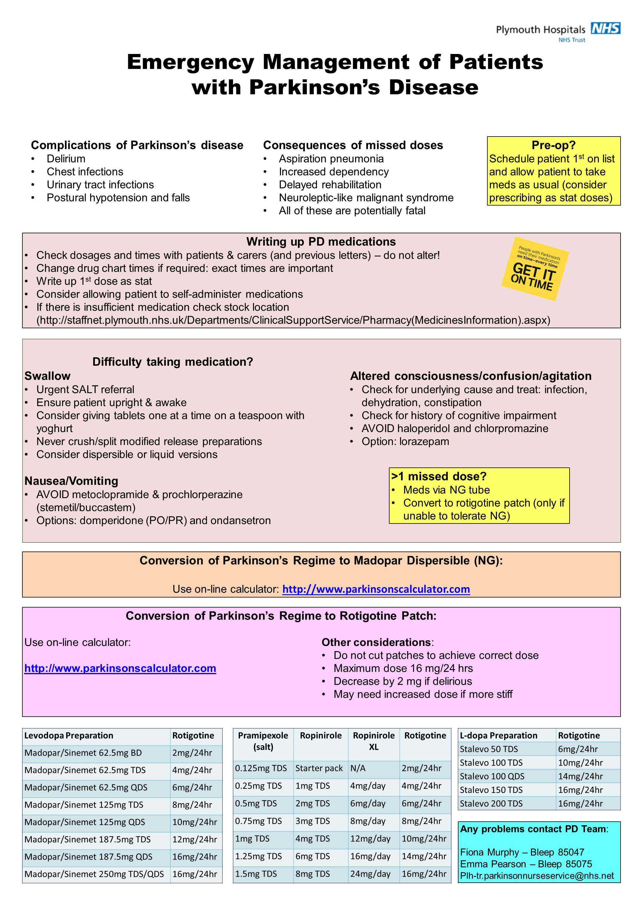

Appendix 5
Pre-op notification proforma for patients with Parkinson’s disease
(Please e-mail form to plh-tr.parkinsonnurseservice@nhs.net)

Pre-operative Assessment

Patient details (affix sticker if available)
Name: DOB:
Address: Hospital number:

Planned operation:

Planned date of operation:

Name of consultant physician caring for patient’s Parkinson’s disease (if known):
Current medication (if known):

Allergies:

b) Pre-operative Checklist for Patients with Parkinson’s Disease

Appendix 6
Pre-operative checklist for patients with Parkinson’s disease
Elective Surgery
Actions | Completed
Ask patient to inform their usual Parkinson’s disease consultant about impending surgery
Complete and fax/email pre-op assessment form
Aim for patient to be placed 1st on the operating list
Ensure PD medications are charted accurately and allow patient to continue medication until the start of induction
Avoid contra-indicated medications
If patient is likely to be NBM post-operatively, consider passing an NG to allow continuation of medications
Emergency Surgery
Actions | Completed
Inform the Parkinson’s disease team (PD nurse or consultant team)
Ensure PD medications are charted accurately and allow patient to continue medication until the start of induction
If patient has missed a dose, give it immediately, followed by the next dose at the usual time.
Avoid contra-indicated medications
If patient is likely to be NBM post-operatively, consider passing an NG to allow continuation of medications
Post-operatively
Actions | Completed
Assess patient’s swallow as soon as possible
If patient is unable to swallow safely, consider alternative routes for medication (via NG or topical)
Ensure patient is able to take their PD medications as usual

PLEASE FILE IN THE PATIENT’S NOTES
Appendix 7
ROTIGOTINE PATCH PLACEMENT CHART

Affix patient ID label here
START DATE: / /

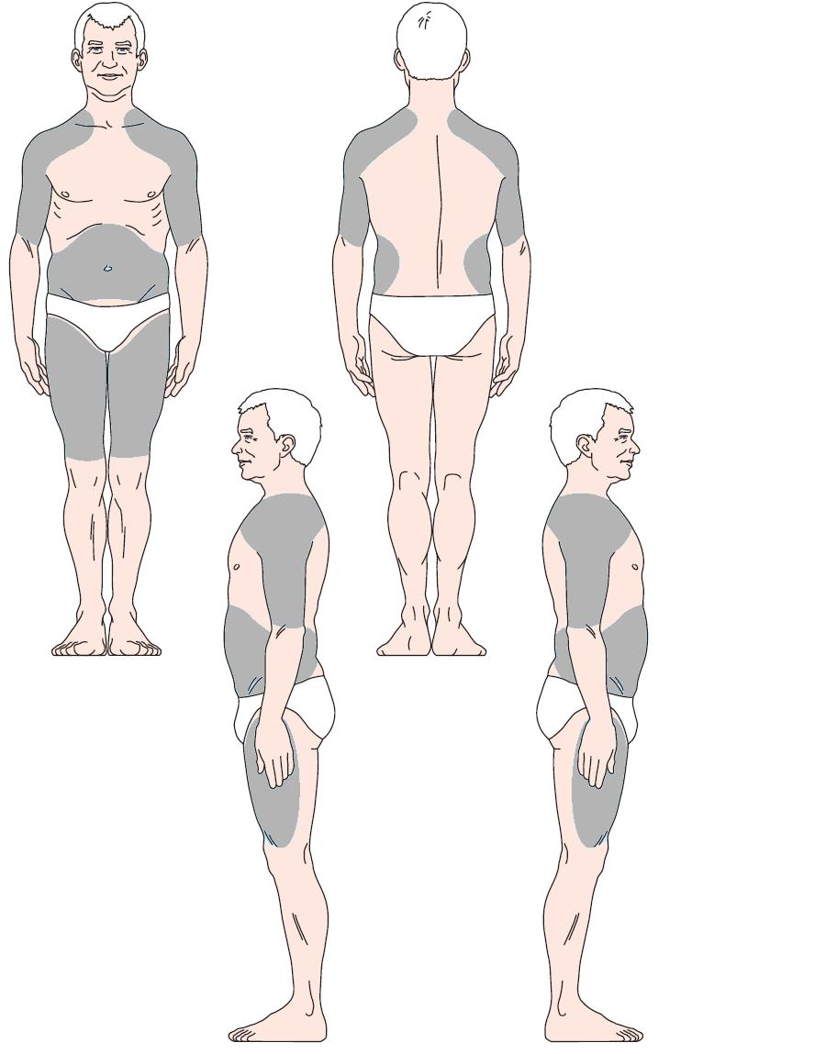
PLEASE FILE IN THE PATIENT’S NOTES

